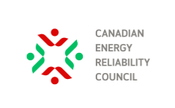

An Electric Grid Primer

August 2025

What does AC and DC mean? 1
What are Line Losses? 1
Why does AC and DC matter? 2
Do generators used on the grid produce AC or DC? 4
Why do wind turbines produce DC, yet other turbines produce AC? 5
What is a synchronous generator? 5
What does inertia mean in the context of the electric grid? 6
What does Dispatchable Generation mean? 7
Can nuclear generation plants ramp quickly? 8
What is Peak Demand? 9
What is Baseload? 10
Can Intermittent Renewables provide Baseload Power? 10
What is Spinning Reserve and why does it matter? 11
What are Inverter-Based Resources and why do I hear a lot about them? 12
What is DER? 13
What is a VPP? 14
What is the difference between Energy and Capacity? 15
What is a Capacity Market? 15

What does AC and DC mean?
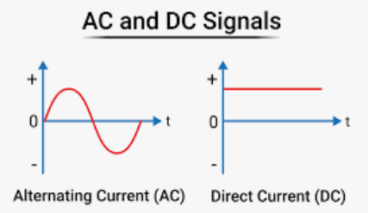
For purposes of illustration, electricity can be thought of as a stream of electrons flowing down a wire. This flow is called a current. AC – alternating current - and DC – direct current – refer to the way the electrons flow. AC flows back and forth while DC is a constant one-directional flow, as shown in the graphs to the left.
Electrons flow when a voltage is applied. Voltage is the force that causes them to move and as a result is also called electromotive force. To create an alternating current requires an alternating voltage and to create a direct current requires a direct, or constant, voltage.
The mathematical description of the AC voltage and current waveform is a sinewave. The amount of time between the times the waveform rises through the x axis is called the period and the number of times it does so in a given time period is called the frequency.

What are Line Losses?
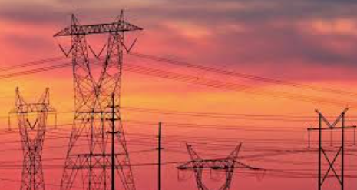
Line losses are the amount of electricity that is lost as it is transmitted along a wire.
As electricity travels down a wire, some of the electrical energy is converted to heat due to the resistance of the wire and is lost. The amount of electricity lost is directly proportional to the square of the amount of current.
The relationship between voltage, current and the total amount of electrical energy is:
P = V * I
Where P = total electrical power which is the amount of electrical energy in a given time period, V= voltage and I =current. From this formula you can see that the higher the voltage is, the less the current needed to deliver the same amount of power.
Given this relationship and the fact that the larger the current the larger the line losses, engineers try to ensure that when transporting electricity over long distances the current is low. To transport the same amount of electric power at that lower current requires them to raise the voltage.

Why does AC and DC matter?
In the early days of electricity production, much electricity generated was DC. However, DC electricity was challenging to transport over large distances at the voltage required by the customer because of the line losses discussed in the previous question.
As we saw, to reduce line losses requires higher operating voltages. However, we don’t want to deliver to a customer at a higher voltage than their appliances need. Therefore, to reduce line losses engineers needed a way to “step up” the voltage for transmission and “step down” the voltage before it is delivered to the customer. DC electricity was difficult to step up and down at that time.
The "War of the Currents" was a late 19th-century conflict between Thomas Edison, who championed DC, and Nikola Tesla along with George Westinghouse, who advocated for alternating current (AC). While Edison's DC system was initially more established, Tesla's AC system proved more efficient for the long-distance transmission of power, ultimately becoming the standard for electricity generation and distribution.
The solution to this problem was a transformer. A transformer steps the voltage up and down as needed, but it only works on AC not on DC.
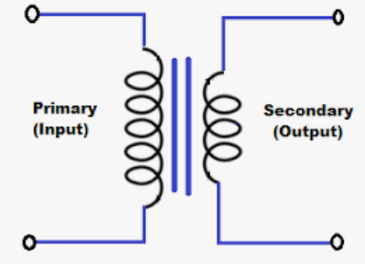
This is because it relies on a fundamental principle of electricity discovered by Michael Faraday. Faraday's law of induction, a cornerstone of electromagnetism, states that a changing magnetic field – such as one caused by a changing current in a nearby coil - induces a voltage in a circuit. This induced voltage is directly proportional to the rate of change of magnetic flux through the circuit. In simpler terms, if you move a magnet near a wire loop or change the current in a nearby coil, you can create a voltage in that loop or coil.
By carefully designing the number of coils in the primary and secondary circuits, the amount of induced voltage can be easily predicted. For the math wizzes out there the “transformer equation” is:
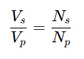
Where:
Vs​: Voltage in the secondary coil
Vp​: Voltage in the primary coil
Ns​: Number of turns in the secondary coil
Np​: Number of turns in the primary coil

Do generators used on the grid produce AC or DC?
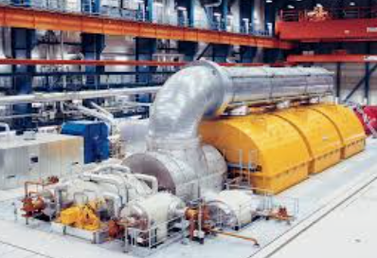
The answer to this question is: it depends. Historically, most generation consisted of a process to convert chemical energy in a fuel, such as converting coal or natural gas, into mechanical energy to spin a shaft. Typically, natural gas is converted directly within a turbine, while coal is typically burned in a boiler and the resultant heat creates steam which drives the turbine.
In the case of hydro-electric generation, the primary energy is gravity, not chemical and in the case of nuclear it is energy released from the fission of atomic nuclei. The heat generated from nuclear fission is used to create steam, which then drives a turbine in much the same way the heat from coal combustion is utilized .
Regardless, whether the primary fuel is chemical, gravitational or nuclear, the result is a spinning shaft. That shaft is connected to a generator, which can be thought of as a lot of coils of wire spinning inside a magnetic field to produce electricity. It uses the same laws of electromagnetic induction we saw in the previous question. Because of the rotation of the generator, the voltage of the electricity produced varies between a negative and a positive maximum which produces AC.
However, intermittent renewables and battery storage systems don’t produce AC, they produce DC which must be converted to AC by power electronic devices called inverters.

Why do wind turbines produce DC, yet other turbines produce AC?
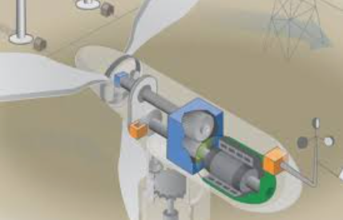
Wind turbines can produce either AC or DC, but most modern grid-connected wind turbines use a variable-speed generator that produces variable-frequency AC, which is then converted to DC, and finally back to grid-quality AC by an inverter. This process is why you often hear that "wind turbines produce DC" — it's a simplification of a more complex system.
For a generator to deliver AC power directly to the grid, its rotational speed must match the frequency of the grid. As we saw in the previous question, grid-connected turbines and hydroelectric generators rotate at a specific, constant speed —to synchronize with the grid frequency.
However, wind speed constantly changes. To capture the maximum energy from varying wind, wind turbines are designed to change their rotor speed — unlike traditional generators (like gas or hydro), which rotate at a fixed speed. This presents a challenge connecting to the grid directly, hence the conversion to DC than back to grid quality AC.
Although they aren’t turbines., solar photovoltaics and battery electric storage devices also produce DC and are connected to the grid through an inverter.

What is a synchronous generator?
By controlling the rotational speed of the turbine and ensuring the design of the turbine and generator are suitable, the generator produces electricity at a frequency that matches the frequency the grid, which is operated at:120 volts and 60 Hz in North America and 240 volts and 50 Hz in most of Europe, Asia and Africa.
Generators that maintain a constant electrical frequency that is synchronized with the power grid are called synchronous generators because they rotate at a fixed speed directly tied to the grid’s frequency.
Maintaining a constant grid frequency is an important task for grid operators and synchronous generators are important to achieving that goal.

What does inertia mean in the context of the electric grid?
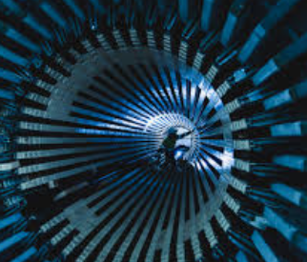
Inertia in the power grid refers to the physical resistance to sudden changes in frequency and is provided by the rotating mass of large, synchronous generators. This inertia is sometimes referred to as mechanical inertia.
Large synchronous generators rely on the kinetic energy stored in their spinning masses to provide the inertia. If grid frequency drops suddenly (e.g., due to a generator failure), the inertia from these spinning machines can temporarily supply energy, thereby buying time for other systems (like fast-ramping generators or batteries) to respond.
As power systems transition to renewables (wind, solar), traditional rotating generators are being replaced by inverter-based resources, which do not inherently provide inertia. The impacts of this trend are:
- Faster frequency drops when unexpected events occur
- Greater risk of blackouts
- Need for synthetic or “virtual” inertia
Synthetic inertia is provided when an inverter- detects a change in grid frequency. Its control software rapidly reacts to slow the rate of frequency change, just like real inertia would. It typically responds within 100–200 milliseconds - faster than traditional thermal generators.
However, while virtual inertia mimics inertial response, it does not physically store rotational kinetic energy, so it cannot fully emulate the stabilizing characteristics of synchronous machines in every situation. Further it requires advanced inverter control algorithms and tuning to avoid instability or interaction with other grid resources. Poorly tuned virtual inertia can exacerbate rather than solve an under or over frequency event.

What does Dispatchable Generation mean?
Dispatchable generation refers to electricity sources that can be turned on, off, or adjusted on demand by a grid operator to meet changing electricity needs. In simple terms: You can control when and how much they generate.
The term “ramping” is closely associated with the notion of dispatchability. It refers to the process of bringing the generation resource up to speed. The faster the ramping time, the more dispatchable the generator is.
The table below illustrates the relationship between dispatchability and ramping.
Type | Dispatchable? | Notes
Natural Gas (CCGT, OCGT) | Yes | Fast ramping, commonly used for peaking or balancing
Hydroelectric | Yes | Highly dispatchable if reservoir-based
Coal | Yes | Slower to ramp, but controllable
Nuclear | Partially | Technically dispatchable, but often run at constant output for economic reasons
Diesel Generators | Yes | Used in remote or emergency situations
Battery Storage | Yes | Extremely fast response; not "generation" in the traditional sense but functionally similar

Not appearing in the table above are wind, solar and run of river hydro. These generation resources are non-dispatchable or have limited dispatchability.
Dispatchability of resources depends very much on the time horizon one is considering. If it is noon and a completely cloudless day, a solar resource may well be dispatchable for the next hour of so – although not so if it is close to sunset. If one has access to a highly reliable favourable short-term weather forecast, the noontime dispatchability could continue for several hours.
However, will that solar resource be dispatchable tomorrow morning? The following day? The further forward one looks, the less dispatchable an intermittent renewable generation resource is.
The resources in the above chart can be relied upon to provide electricity at any time. This, of course, is subject to the availability of fuel and assumes that the plant is operational and suffers no breakdowns.
The only possible exception is battery storage. A battery only holds a finite charge. For example, most grid-scale lithium-ion battery systems are designed for 2 to 4 hours of full-power discharge, although some newer installations target 6–8 hours using more energy-dense configurations. For example, a 100 MW / 400 MWh battery can deliver 100 MW for 4 hours.

Can nuclear generation plants ramp quickly?
Generally speaking, nuclear power plants have historically not been designed for rapid ramping, as they have traditionally served as baseload generation. Nuclear reactors rely on complex thermal systems, which respond slowly. Rapid changes can affect fuel integrity, neutron flux, and thermal stresses in key components.
Reactor Type / Country | Typical Ramping Rate
Conventional PWR/BWR (e.g., U.S.) | ~1–5% of capacity per minute (slow)
French PWRs (Load-following capable) | ~5%/min, up to 80% → 20% in 30 minutes
CANDU (Canada) | Historically baseload, some limited ramping
Modern SMRs (e.g., NuScale) | Designed for flexibility; 5–10%/min potential
German/Swiss PWRs | Also capable of ~5%/min in some cases

However, modern designs, particularly SMRs, and some national fleets (like in France) have greater flexibility. In France’s case that is because the country relies on nuclear for more than 70% of its electricity and needs that ramping capability from its nuclear fleet.

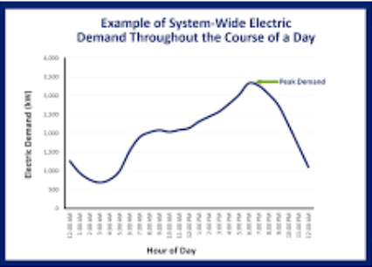
What is Peak Demand?
It is important to recognize that we can’t look only at the overall amount of electricity that is required to meet customer demand. We must also consider when that electricity is needed - it is the morning and/or evening peaks that determine how much and what type of generation we need available, even though those peaks may only last for a relatively small proportion of the whole day.
This is analogous to the considerations around building transportation infrastructure. A six-lane freeway with three lanes each way that connects a distant suburb to the downtown core may only have three of its six lanes utilized for a few hours a day, either in the morning or the afternoon, depending upon which side of the road you look at. During off peak hours, two or even one lane each way may suffice.
Looking more closely at the intra-day demand, it is different for every day of the year. In Canada, most utilities historically experienced their largest peaks in the winter, although with the increased use of air conditioning, summer peaks have been increasing for some time.
Ontario’s summer peak exceeded its winter peak almost 20 years ago. The summer (and all-time) peak for Ontario’s electricity demand was set on August 1, 2006, at 27,005 MW. The all-time highest winter peak demand was 24,979 MW, set on December 20, 2004.
Why does the peak load matter? Like freeways, electricity systems must be designed to meet not just the average load but also the peak.

What is Baseload?
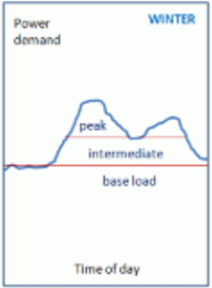
Baseload refers to the minimum level of continuous electricity demand on the grid over a 24-hour period.
The graph to the left illustrates the demand for electricity on a typical winter day. There is a peak in the morning, when people are getting up, probably turning on lights and preparing breakfast, then a similar peak in the evening.
Electricity to meet baseload demand has historically been provided by coal, nuclear, large reservoir hydro and, to a much lesser extent, natural gas. While these resources are the most economic and reliable to provide baseload power, they are not necessarily the fastest ramping – and don’t need to be in their role as baseload power providers.

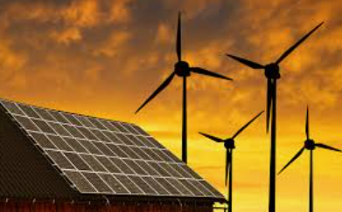
Can Intermittent Renewables provide Baseload Power?
The answer to this question is nuanced. Baseload power requires a fully dispatchable generation resource. A single intermittent renewable generation resource cannot provide baseload power because it isn’t dispatchable - it can’t be relied upon to be “always on”. The same is true for a group of intermittent generation resources, such as a wind farm. However, the more geographically dispersed the intermittent generation resources are, the more likely that at least part of the group will be producing even if others aren’t. It is likely that the geographic dispersion needed of wind is less than required of solar.
Connecting a geographically-disperse collection of intermittent generation resources will require additional transmission. Further, the amount of baseload power that such a collection may be able to provide will be less than the sum of the rated capacity of each of the individual resources.
That said, in this sense, intermittent renewables can provide some baseload power, although there is always a risk that the sun won’t be shining or the wind blowing in any of the geographic footprint.
Perhaps because of this, some grid planners and analysts are moving away from the term "baseload" in favor of a more flexible mix:
- Dispatchable generation (e.g. gas, hydro)
- Variable renewable energy (e.g. wind, solar)
- Storage and demand response

What is Spinning Reserve and why does it matter?
Spinning reserve is backup generating capacity that is:
- Online (already synchronized with the grid),
- Running at less than full load, and
- Able to ramp up power output quickly (typically within seconds to a few minutes)
It is used to maintain grid reliability in case of a sudden generator, transmission or other failure or a large, unexpected increase in demand.
Technologies that providing spinning reserve include:
- Gas turbines
- Hydroelectric units
- Diesel generators
- Battery energy storage (for fast frequency response — not traditional spinning, but now accepted in some cases)

What are Inverter-Based Resources and why do I hear a lot about them?
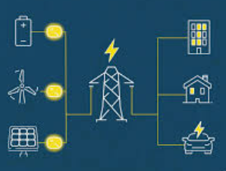
Historically, most generation resources have generated AC and been connected synchronously to the grid. In contrast, wind and solar-based resources along with Battery Electric Storage Systems produce DC, which must be converted to AC before connecting to the grid. This conversion is done by an electronic device called an inverter. Collectively then, wind, solar and batteries are referred to as “Inverter-Based Resources” or IBRs
While generally IBRs work fairly seamlessly, there are occasions where they can lead to, or contribute to, instabilities on the grid. Areas of particular concern are:
- Ride-through: This refers to the ability of a generator to remain connected to the grid in the face of voltage or frequency fluctuations. Typically synchronous generators will ride through such fluctuations. However, many inverters will disconnect from the grid in these circumstances.
- Grid following is an inverter based resource that synchronizes to the voltage and frequency of the existing electrical grid, rather than setting them. It is dependent on a live grid signal to operate. Am inverter based resource that doesn’t need a signal from the grid to operate in considered grid forming.
- Grid-forming capability is essential to maintain stability is especially critical for the following situations:
  - Isolated systems (islands, microgrids).
  - Low-inertia grids (grids with high intermittent renewable penetration).
  - Black start recovery of the grid after a major outage.
- inverter based resource would be uanable to
- Black Start. This is the ability of a generator, in the event of a grid shutdown, to restart the grid.
- Potential back door vulnerabilities. Inverters almost all have some form of remote connectivity to enable remote control by legitimate owners and operators. Depending on where they are physically, a cellular network connection might be the only practical way to connect to them. Therefore, many inverters are vulnerable to malicious actors attempting unauthorized entry.
These are in addition to the need for grid operators to ensure that there is sufficient back-up generation if electricity from renewable generation resources isn’t available in the face or a demand spike or the loss of other generation.
A recent example of the availability challenges faced by IBRs was brought home in the UK on 8 January 2025 during the tightest day since 2011. The spare margin – the surplus generation capacity available to meet demand – fell to worryingly low levels, with a real risk of demand control or even a blackout. Read the report here.
For more on inverter-based resources and grid stability, the experts break it down here.

What is DER?
A Distributed Energy Resource (DER) is any small-scale electricity supply or storage technology that is connected to the distribution system close to the point of use, rather than at large central power stations or on the transmission system. They can be connected behind a customer’s meter.
Some examples of DER include:
- Generation
  - Rooftop solar PV
  - Small wind turbines
  - Micro-hydro units
  - Natural gas microturbines
- Storage
  - Residential or commercial battery systems
  - Electric vehicle batteries (when used for grid services)
  - Thermal storage (ice storage for cooling)
- Flexible Loads
  - Smart appliances that can adjust demand
  - Electric vehicle charging that can be scheduled or curtailed
DER resources can provide resilience by supplying power during outages in islanded or microgrid mode. However, they can also present challenges, including:
- Coordination: Large numbers of DERs require advanced control systems like Virtual Power Plants (VPPs).
- Grid Impact: High penetration can cause voltage fluctuations, reverse power flows, or protection coordination issues.
- Regulation & Market Access: Many markets are still updating rules to allow DERs to participate in wholesale markets, which typically only operate on the transmission system.

What is a VPP?
A Virtual Power Plant (VPP) is a coordinated network of small, distributed energy resources (DERs) — such as rooftop solar panels, home batteries, electric vehicle chargers, smart appliances, and flexible industrial loads — that are aggregated and managed by software to operate like a single power plant in electricity markets.
Instead of being a single large facility like a coal or gas plant, a VPP is virtual because the assets are geographically dispersed, but are digitally connected and centrally controlled.
The U.S. Department of Energy estimates that 30 to 60 gigawatts (GW) of VPP capacity are currently operating on the grid using commercially available technologies.
- In Germany and the UK, Statkraft manages a VPP aggregating over 1,000 renewable energy sources, with a combined capacity exceeding 10 GW.
- In Australia, Tesla’s South Australian VPP has approximately 35 MW of capacity through approximately 7,000 Powerwall installations as of late 2024
- In Texas, Bandera Electric Cooperative’s VPP (via at-home batteries and solar systems) currently contributes around 25.5 MW and is part of a pilot program aiming to expand up to 80 MW.
- During a recent heat dome in the U.S., 75 VPP projects featured 1.5 GW of capacity, serving about 3.9 million enrolled customers; this is still a fraction of the total DOE estimate

What is the difference between Energy and Capacity?
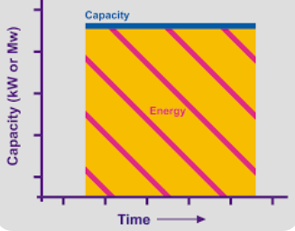
Energy is the total amount of electricity produced, consumed, or stored over a period of time, measured in megawatt-hours (MWh) or kilowatt-hours (kWh).
Capacity is the maximum instantaneous output a generator or storage device can produce or deliver, typically measured in megawatts (MW) or kilowatts (kW).
Capacity is often used to denominate the size of a power plant or battery - it tells you how much power can be delivered at a given moment.


What is a Capacity Market?
A capacity market is a type of electricity market that ensures there will be enough generating capacity available in the future to meet peak electricity demand — even if that capacity is not used frequently. These markets enable customers to pay power plants (and other resources) to be on standby, so they’re ready when needed.
Capacity markets typically operate years in advance. For example, PJM's Base Residual Auction is 3 years ahead. This is an attempt to ensure there will be enough capacity to meet peak demand in the future. The longer time scale also enables providers to develop and add capacity which may require construction of new plants or expansion of others.
Sellers commit capacity which may not necessarily produce energy. However, they are paid simply to be ready and do not need to provide any energy in order to be paid.

60 Hz (or more formally 60 Hertz) means that the voltage and the current go through 60 complete cycles - from 0 through the negative maximum, back through zero and the positive maximum and back to zero again - every minute.
For a discussion of synchronous generators please see the question: What kind of electricity do generators connected to the grid produce?
https://www.ieso.ca/Learn/Electricity-Facts-and-Tools/Electricity-Facts?utm_source=chatgpt.com
The maximum output a generator, power plant, or energy asset is designed to produce under ideal conditions, as specified by the manufacturer.
A grid management strategy where electricity consumers are incented to reduce or shift their electricity use during periods of high demand
https://www.energy.gov/lpo/virtual-power-plants-projects?utm_source=chatgpt.com
https://www.helindata.com/blog/guide-to-virtual-power-plants-vpp?utm_source=chatgpt.com
https://www.news.com.au/technology/environment/hand-over-the-keys-tesla-to-sell-800-million-virtual-power-plant-in-south-australia/news-story/2a793d6f5183922938138369fdaaa619?utm_source=chatgpt.com
https://www.expressnews.com/business/article/virtual-power-grid-texas-ercot-solar-electricity-20177395.php?utm_source=chatgpt.com
https://www.utilitydive.com/news/virtual-power-plants-helped-save-the-grid-during-heat-dome/753247/?utm_source=chatgpt.com

